**Job Application Tracking System**

**Project Description**

Create a CRM Application which helps the applicant to track the No. of jobs he applied and

helps him to find the job posted by the various recruiters, find the best attributes to be involved

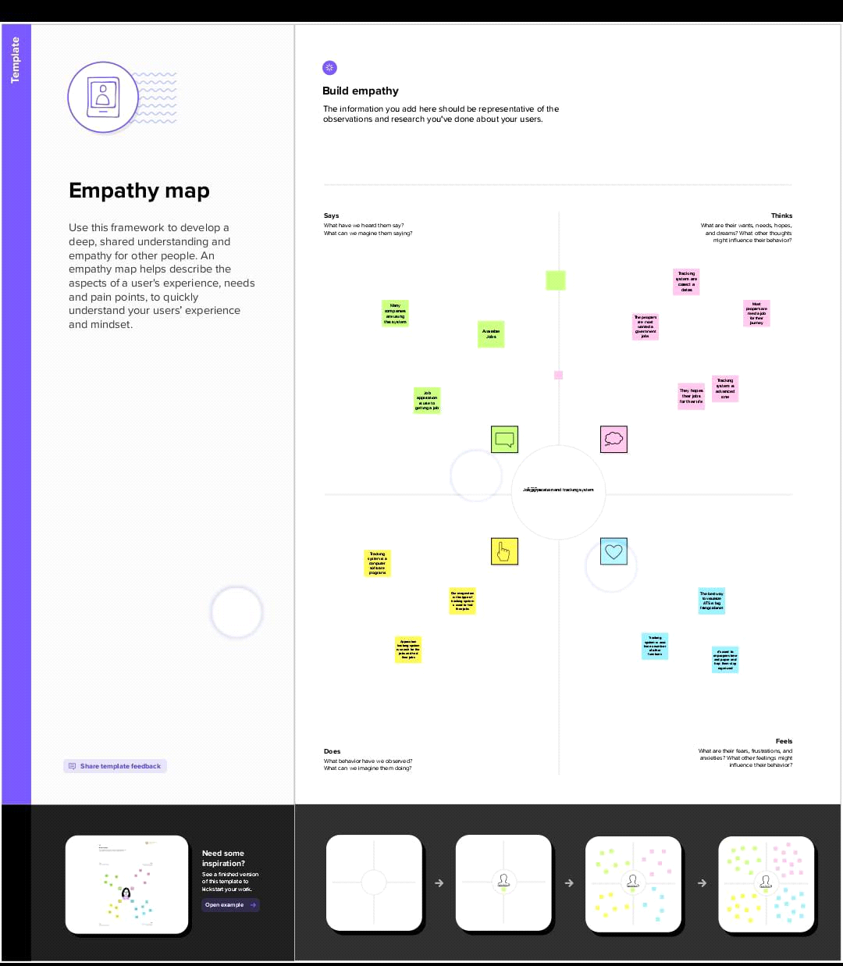

to run the process in a smooth way and easily to track.

**Create a Data Model for the App**

To make the existing app more efficient for the Job application we create custom objects and

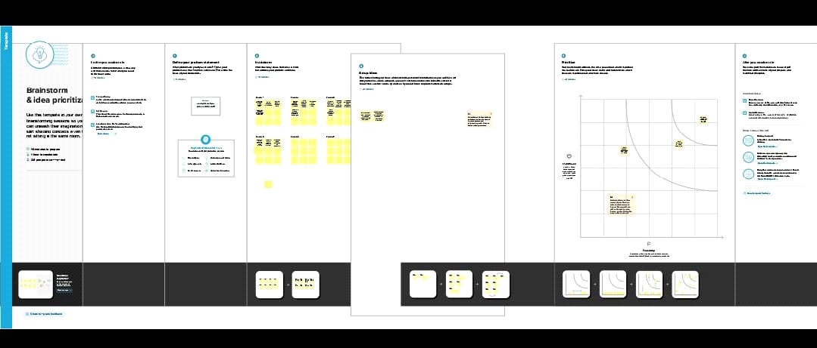

relationships to store and access the data more efficiently.

**Introduction**

Are you new to Salesforce? Not sure exactly what it is, or how to use it? Don’t know where you

should start on your learning journey? If you’ve answered yes to any of these questions, then

you’re in the right place. This module is for you.

Welcome to Salesforce! Salesforce is game-changing technology, with a host of

productivity-boosting features, that will help you sell smarter and faster. As you work toward

**Milestone 1- Salesforce:**

**Activity1:**

**Creating a Salesforce Developer Org:**

A Developer org has all the features and licenses you need to get started with Salesforce.

1. Search Developer.salesforce.com

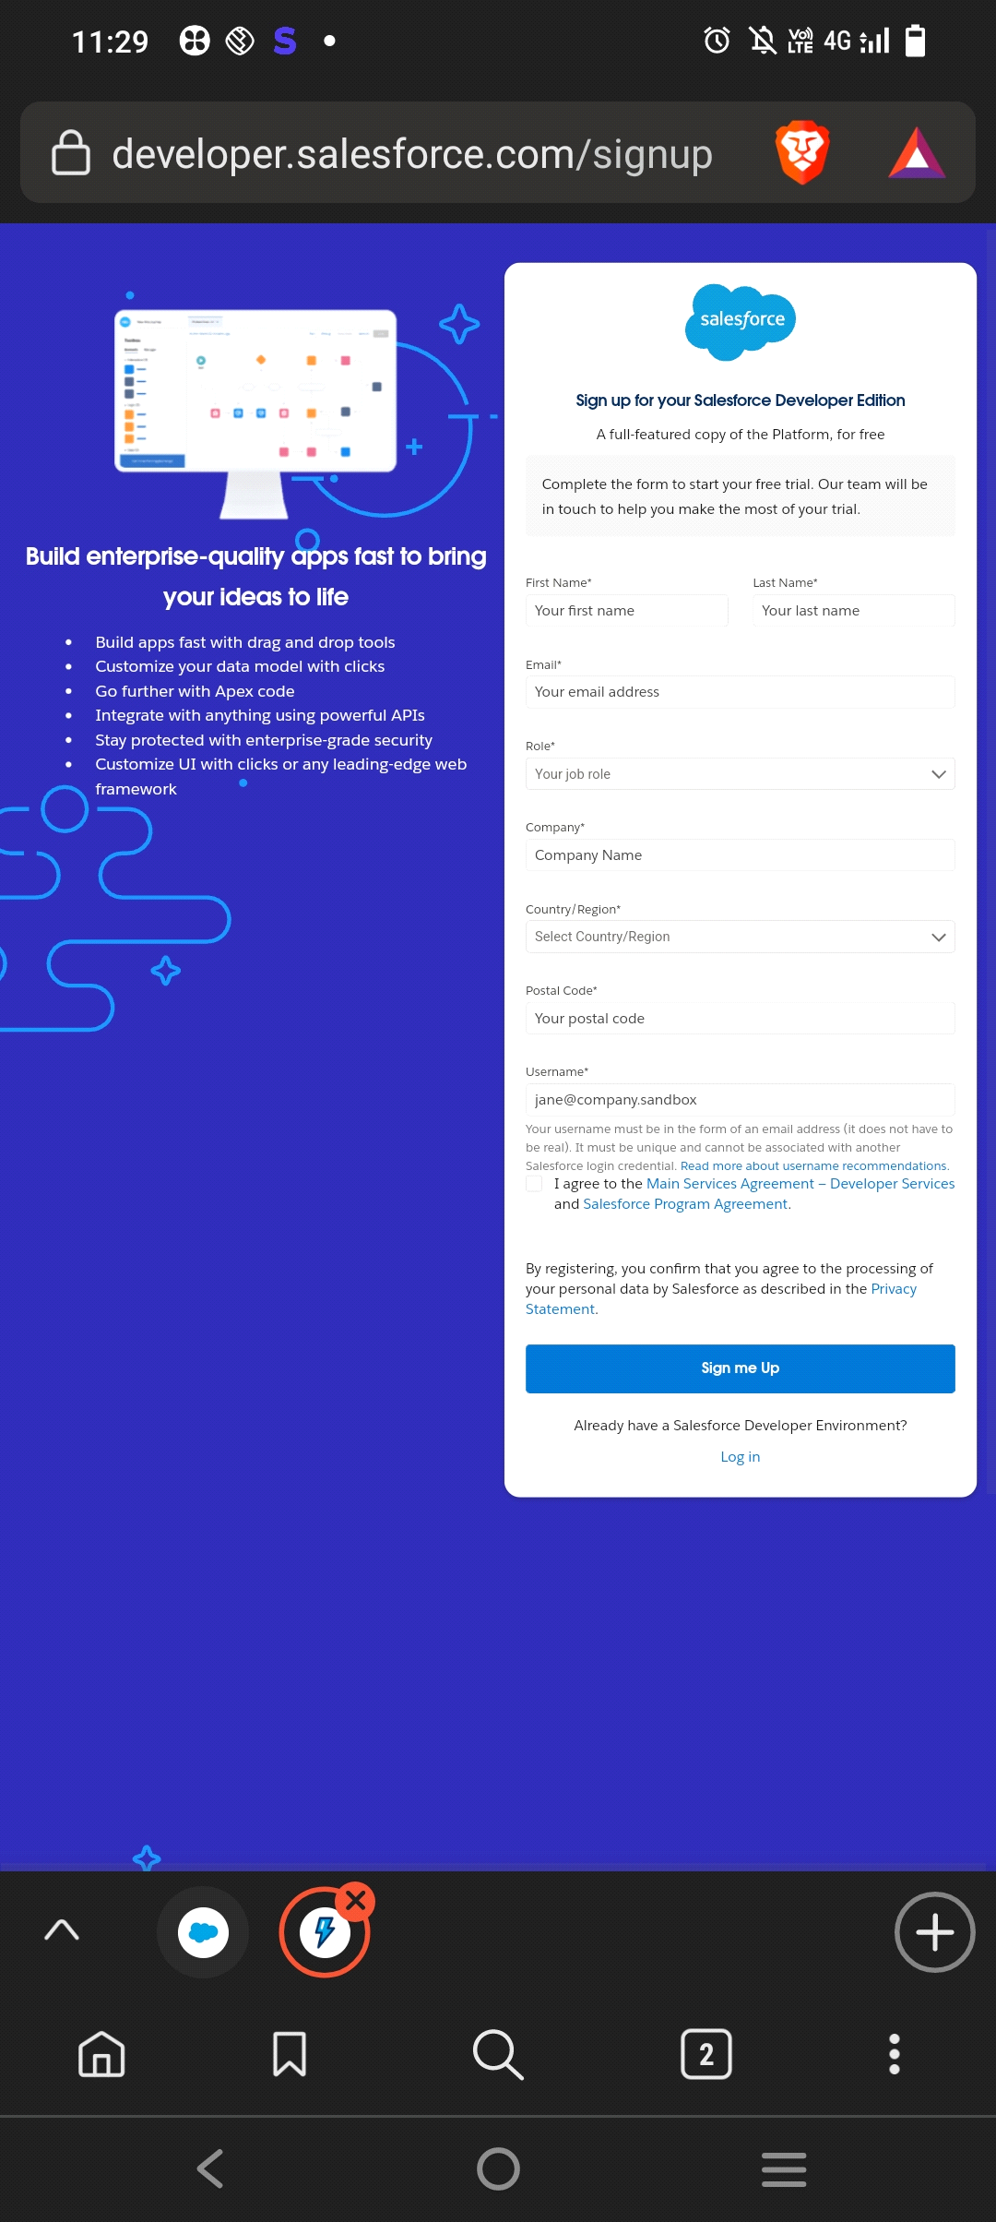

2.Enter the following details like First name, last name, Email, Role, Company, Country/Region,

Postal code, and Username must be unique.

3. Click sign me up, after a few min you will reserve a mail salesforce org and by using the

verify account link you can create your new password.

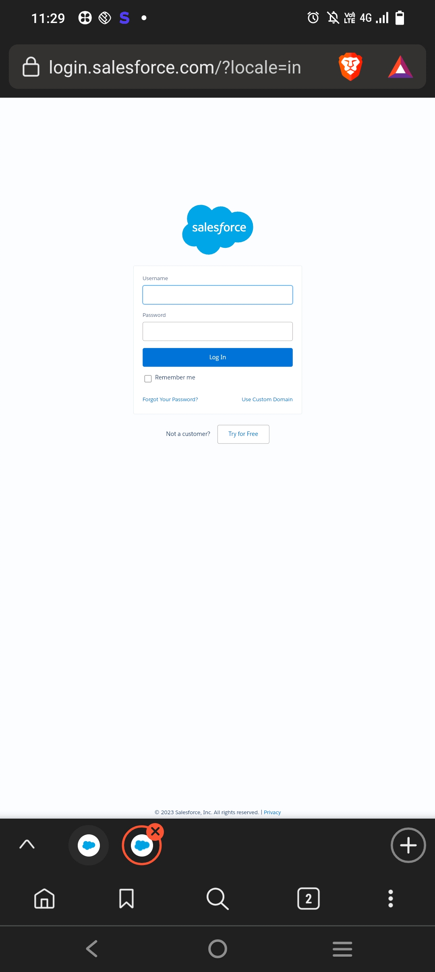

4. Click save.

5. Search login.salesforce.com

6. By using username and password you can into the salesforce org.

The setup page will appear as below.

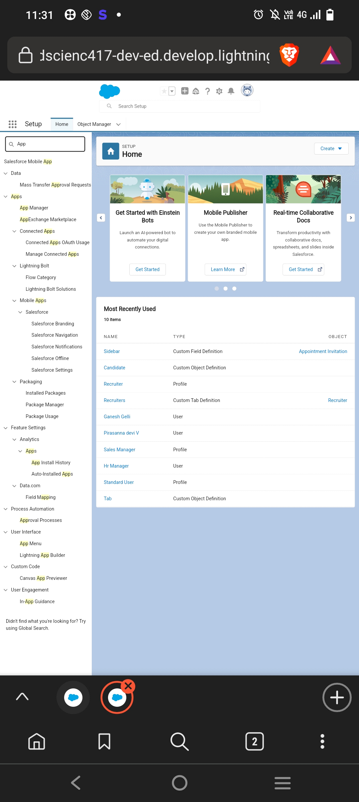

**Milestone 2-Object:**

**Activity 1:**

**Create a custom object for Recruiter:**

To create a custom object, follow these steps:

1. From setup click on object manager.

2. Click create, select custom object.

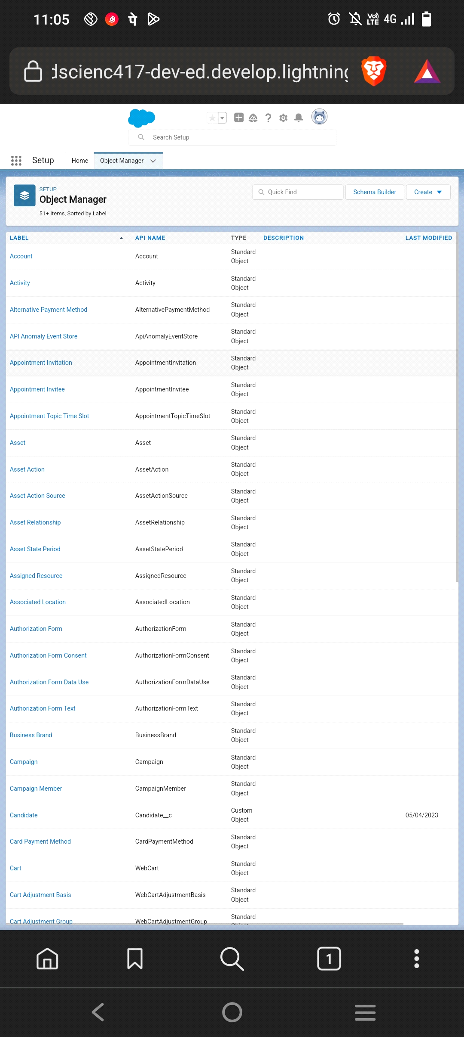

3. Fill in the label as " Recruiter ".

4. Fill in the plural label as " Recruiters".

5. Record name: " Recruiter Number"

6. Select the data type as "Auto Number".

7. Under display format enter "REC-{0000}".

8. Enter starting number as 1.

9. In the Optional Features section, select Allow Reports and Track Field History.

10. In the Deployment Status section, ensure Deployed is selected.

11. In the Search Status section, select Allow Search.

12. In the Object Creation Options section, select Add Notes and Attachments

related list to default page layout.

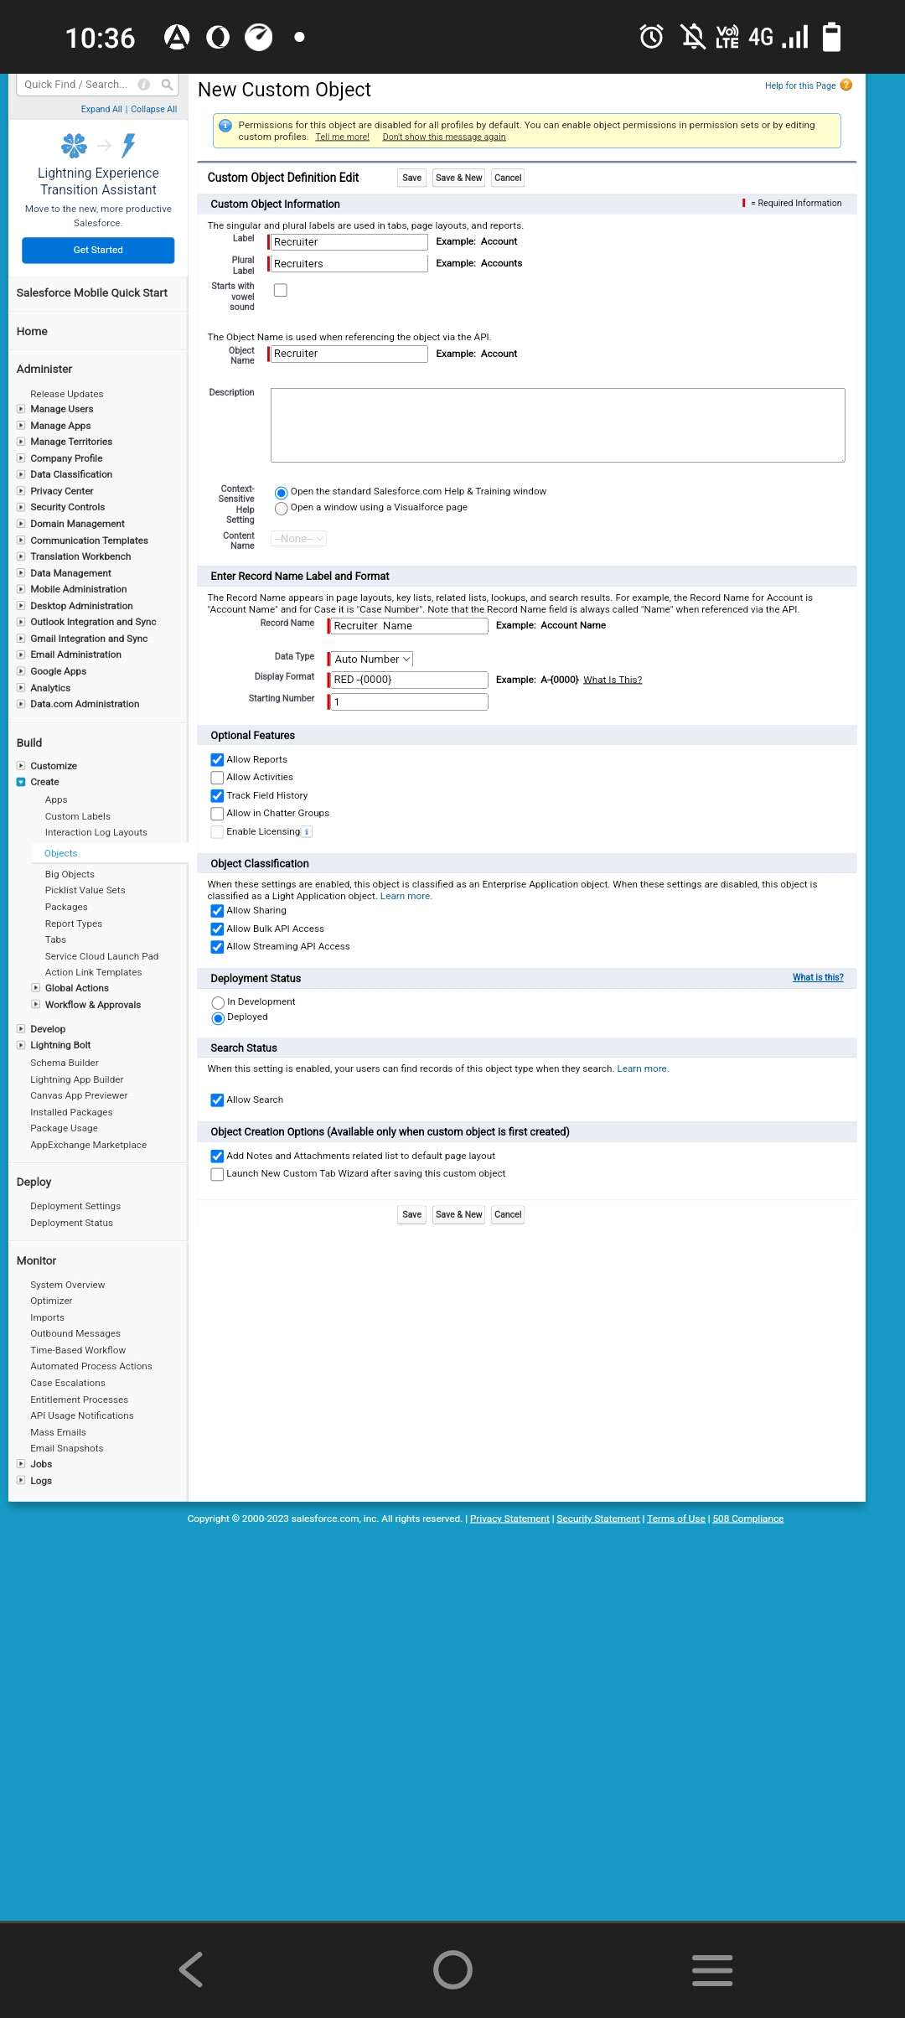

13. Leave everything else as is, and click Save.

**Activity 2:**

1. Create a Jobs, Candidate, Job Application Object and Tab.

Note :- Follow the steps from the above activity

**Milestone 3**

**Activity 1:**

**Create the custom fields:**

1.Click the object manager tab, Select the object for which you have to create the fields and

relationships.

2.From the sidebar, click Fields & Relationships. Notice that there are already some fields there.

Those are the standard fields.

3. Click New to create a custom field. Tip: Before creating a new field, do a quick search to

make sure a similar one doesn’t already exist.

4. Click on the new to create a field.

5.Choose the data type as a Text, click next

6.Enter field label, length and Name and click next

7.Select the profiles to which you want to grant edit access to this field via field-level security.

The field will be hidden from all profiles if you do not add it to field-level security. Click next

8.Select the page layouts that should include this field.

9.Click save.

**Activity 2:**

**Creation of Master-detail relationship:**

1. From Setup, go to Object Manager

2. On the sidebar, click Fields & Relationships.

3. Click New.

4. Choose Master-detail Relationship and click Next

5. Choose the related object and select that object.

6. Enter the label and name for the lookup field

7. Click Next, Next, and Save

**Activity 3:**

**Create a new custom field:**

1. From Setup, go to Object Manager

2. On the sidebar, click Fields & Relationships.

3. Click New.

4. Choose the data type Text Area click next

5. Enter the Field Label and field name click next

6. Click next and save.

**Activity 4:**

**Create a new custom field:**

1. From Setup, go to Object Manager

2. On the sidebar, click Fields & Relationships.

3. Click New.

4. Choose the data type Text click next

5. Enter the Field Label and field name click next

6. Click next and save.

**Milestone 4-Tab:**

**Activity 1 :**

**Create a tab :**

1. Click setup

2. Search tab in Quick box then, select tab

3. Click New custom object tab section

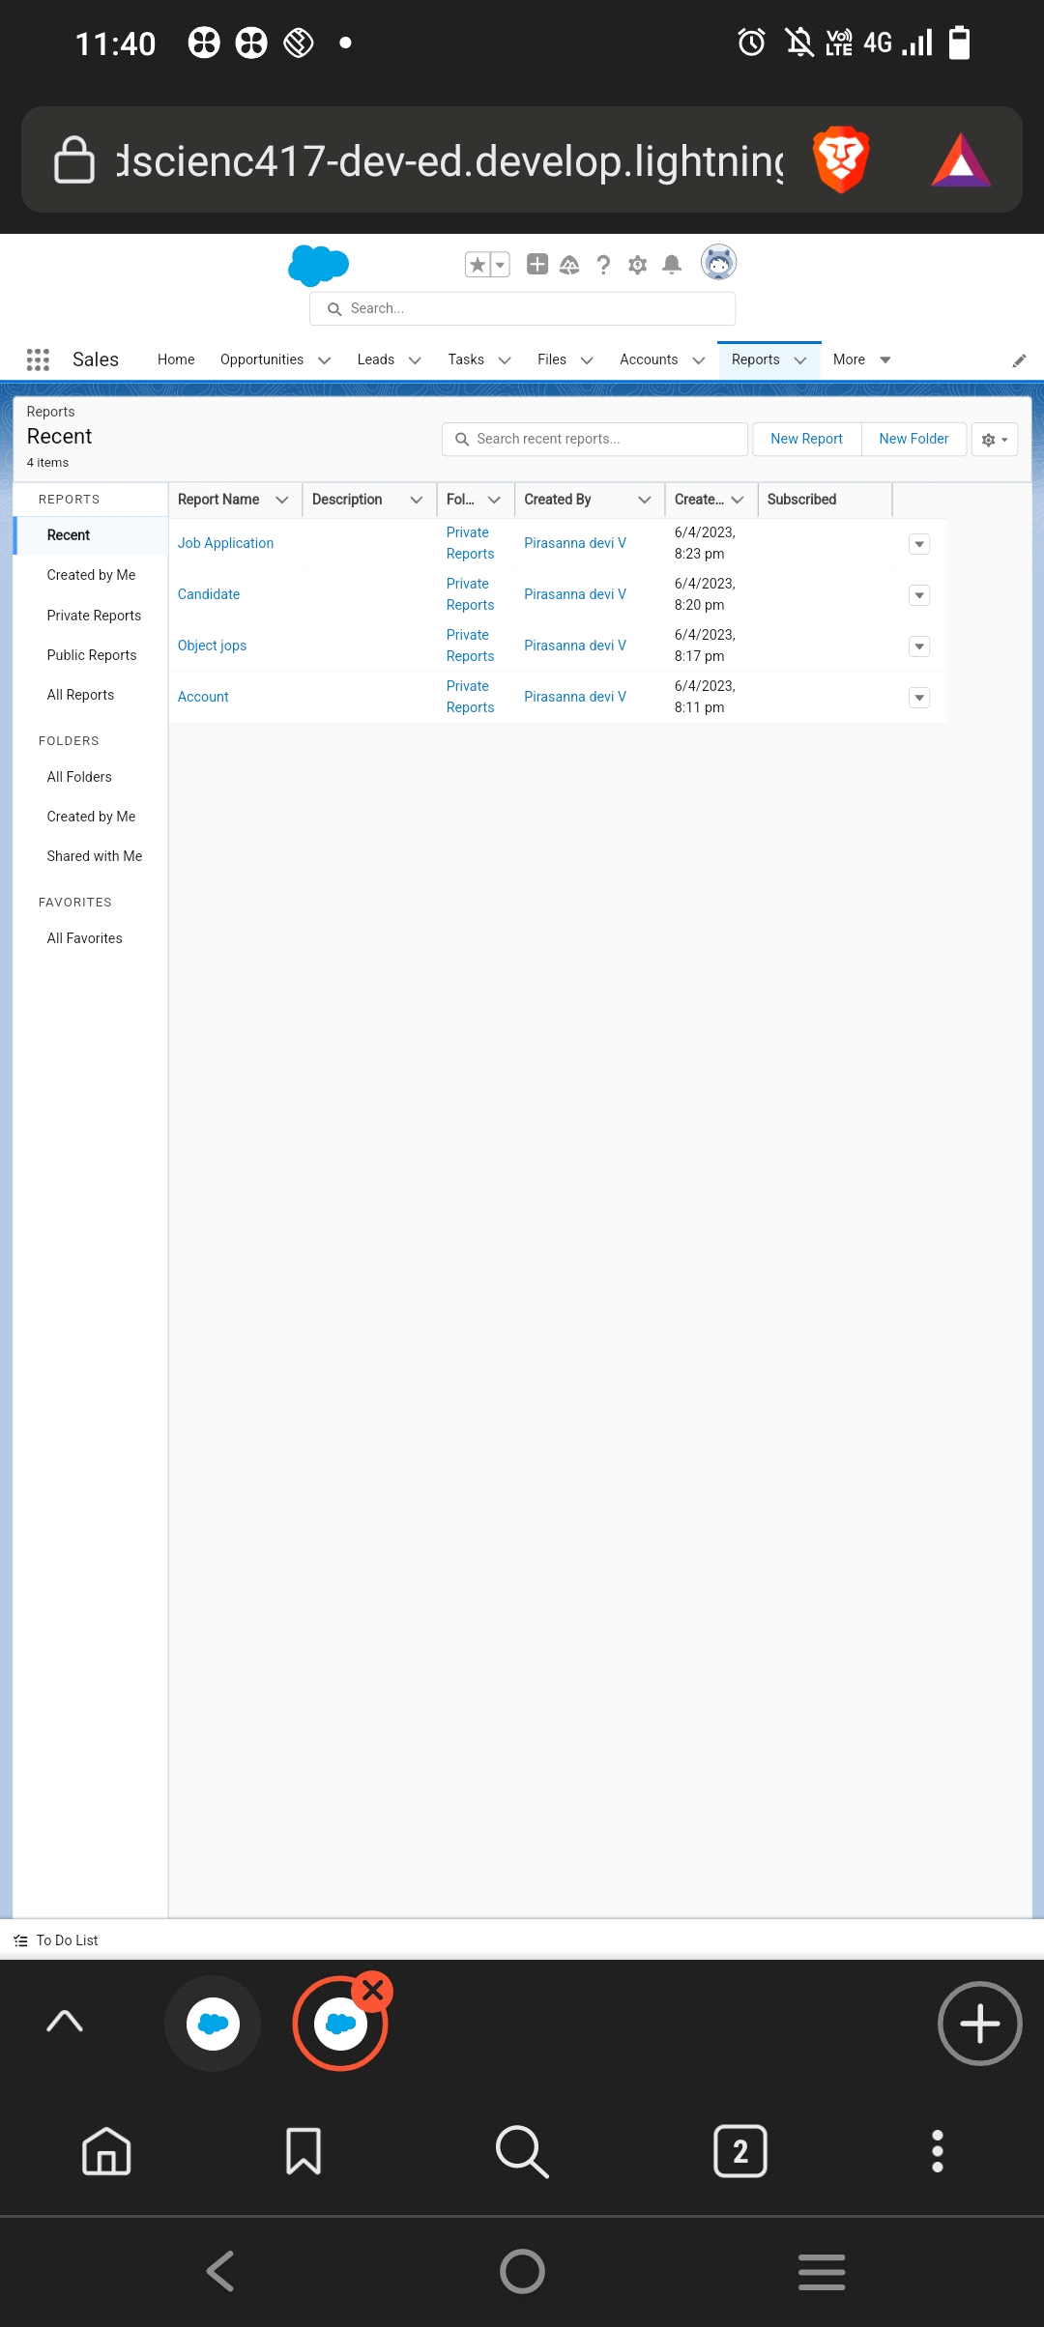

4. Select the created object Recruiter and tab style for the new custom tab.

5. Select the profiles that visible in the tab

6. Click on custom apps to make visible.

7. Click save.

**Milestone 5- Profile:**

**Activity 1:**

**Create a custom profile :**

1. From setup , enter profiles in Quick Find box

2. Select profiles.

3. Click clone.

4. For Profile, enter Recruiter.

5. Click save.

**Activity 2:**

Create a profile with the profile name as “Sales Manager”.

Follow the steps from above Activity

**Milestone 6-User**

**Activity 1:**

**To Create a user:**

1. From Setup, enter Users in the Quick Find box, then select Users.

2. Click New User.

3. Enter First name as Hr and last name as Manager.

4. Enter the user’s name and email address and a unique username in the form of an email

address. By default, the username is the same as the email address.

5. Then create a new role Hr Manager.

6. Select user License as Standard Platform User.

7. Select profile.

8. Click save

**Activity 2:**

Create a user with a username as “Ganesh Gelli”, and assign him the sales Manager profile.

Follow the steps from above Activity

**Milestone 7-Sharing Rules**

**Activity 1:**

**Create a sharing rule**

1) Go to Sharing Settings, which can be found under the Quick Find section.

2) Scroll down and find the candidate object where a sharing rule needs to be added, and then

click on New to create a new sharing rule.

3) Add the label of the sharing rule you want to make.

4) Select your rule type based on the criteria.

5) Select the field can join immediately check field from the candidate object.

6) Select the operator as equal and value is true.

7) And in selecting the users to share with the section select roles and in that select Hr Manager.

8) And in the section of select the level of access for the users give the access Read/Write.

9) And save the rule.

**Activity 2:**

Create a Sharing Rule to Share the records of Job Application to Hr Manager with the Access of

Read/Write.

Follow the steps from above Activity.

**Milestone 8-Reports:**

**Activity 1:**

**Create a report:**

Create a report that displays rating of the account and which has type and account name.

1) Click on app launcher search for reports.

2) Click on the new report and select the category has accounts and contacts.



3) And the report type has accounts.

4) In the details section select the option start report.

5) In the filter pane select All accounts to show me.

6) And All time is created.

7) In the outline pane, group rows select Rating and in group columns select Account Name.

8) In the columns section add Type and Billing city.

9) Save the report by giving label name and save the folder as a public folder and save the report.

**Activity 2:**

Create a Report using the Objects Jobs, Candidate and Job Application.

Follow the steps from above Activity.

**Trailhead profile public URL**

**Team Lead -** <http://trailblazer.me/id/pirav48>

**Team Member 1 - <https://trailblazer.me/id/ramak199>**

**Team Member 2 - <https://trailblazer.me/id/ramac233>**

**Team Member 3 - <https://trailblazer.me/id/rammi21>**

**ADVANTAGES & DISADVANTAGE**

**ADVANTAGES**

**Driver safety**

Statistically speaking, a motor vehicle crash happens approximately every 5 seconds. Peak hours in a busy rural area won’t make things easier. Fleet managers need to know how to educate drivers on safe driving practices. And having a driving behavior report, or a driver scorecard helps identify the behaviors that need to be addressed. In many countries, it is the law that all vehicles are also equipped with an on-board camera that will record all types of incidents for future reference.

**DISADVANTAGES**

Companies receive tons and thousands of CVs and job applications for the advertised vacancies. Shortlisting the candidates become a challenging task. But with the aid of the [**applicant tracking software**](http://www.appliview.com/) things are made easier and simpler. The [**recruiters**](http://www.appliview.com/) of the companies don’t have to spend weeks evaluating all the application step by step. [**ATS**](http://www.appliview.com/) automatically sorts out the candidates as applicable.

**APPLICATIONS**

Collect, sort, and screen resumes and any associated candidate information

Manage talent pools within a custom workflow

Enable communication between HR personnel, hiring manager, or recruiter and candidate

**CONCLUSION**

Leaving tradition behind, the recruitment-technology domain has added new aspects and innovative features, making [ATS](https://aviahire.com/) the core of the recruitment industry.

**FUTURE SCOPE**

The world knows that Applicant Tracking Systems (ATS) made their way into the recruitment domain just a few years ago. Although, previously, ATS solutions were implemented only by a few companies that could bear the heavy investment costs, now their use in the HR arena has risen to a great extent. According to a recently released [survey report](https://www.naukrirms.com/blog/author/naukrirms/), the majority of staffing firms worldwide will opt for an Applicant Tracking System by the end of 2025 to improve the overall talent acquisition efficacy, in this scope the future of ATS definitely looks bright.